

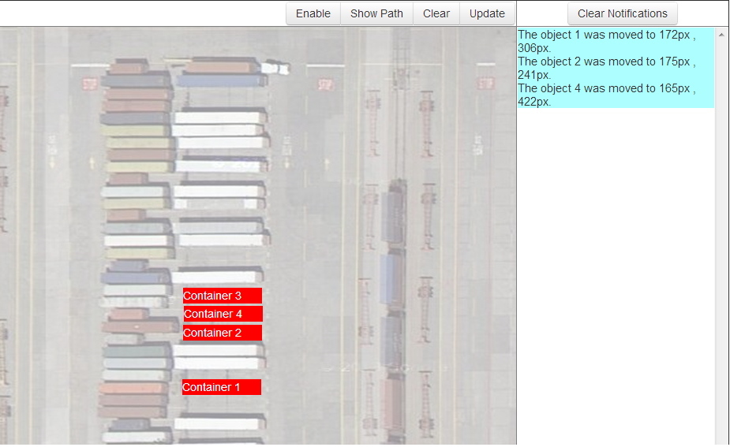

Abstract

Currently existing systems for managing assets (containers, chassis, etc.) at the intermodal hubs are with limited options and functionalities to get a constant update on the current location and status of assets. It will be easier for the hub manager if he gets to visualize this information in form of map-based layout of the hub to track and mobilise his assets in a more efficient manner with much less time required for relocating them.

Real-time Visualization of Location and Movement of Assets in an Intermodal Hub

BTE logo-Sep'11.png

www.infosys.com

Main Features:

* Real-time visualization of asset location and asset movement using a map-type layout for the intermodal hub displaying the assets along with their current status and other information.
* Constant updates for users notifying about the recent movements of assets along with other information regarding the movement.
* Pause/Play feature for the display of movement of assets with the movements while paused displayed using a button.

Asset Information

The information about the assets, i.e. containers, chassis, etc. include their current location, its contents, source, destination and other details. Now this information is uploaded mainly manually which can be inconvenient for users sometimes in need for that information which hasn’t been uploaded yet.

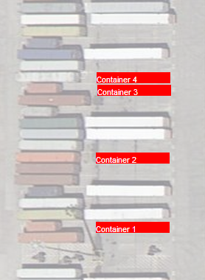

So, this information if updated at any point of time, all logged-on users need to be notified of the updates at real-time.

Also all the information regarding the assets remain stored at a central database which is currently accessible only by visiting some webpage. But it would be better if this data would be provided in a much more interactive and visual manner and all the update operations performed from the same page.

As a solution, our application provides an interactive user interface which along with real-time visualization for the asset location and asset movements gives all the required information about the asset.

Possible solutions for viewing asset status and information:

* Display of asset information as pop-up when mouse pointer is hovered over the asset.
* Colour coding of assets to display its status as well as its properties.
* Keeping a collapsible inventory for the asset information accessible by authorized users.

Visualization of Asset Location & Asset Movement

In the existing asset tracking system the location is given by its Row no. , Lot no. & Spot no. But it might be difficult to keep track of an asset using these parameters if a schematic of the hub is not known. So it would be a better option for tracking if the required location is visualized in form of a hub map which will be easier to refer to for hub managers or authorized users as it requires no prior knowledge of the hub layout.

The asset location information along with other information is stored in the database. Now when an asset is moved by a truck or by a train from one location to the other or somewhere within the intermodal hub, a user updates its movements. This update is visible when the concerned user checking the particular asset information refreshes his webpage. But if a user forgets to refresh the page, he might end up with some information which is incorrect.

So the updated data should be visible to other users as soon as the update operation is performed. Using this application, the change in the asset location can be done by just dragging and dropping the asset from one location to the other. This movement is visible to all other users along with display of change in its status by changing of its colour and also the movement along user’s display screen updates its location in the central database. While a movement of an asset is being done no other user can move it elsewhere. Also, the required information about a particular movement will be available with the notifications where all recent movements will be recorded. Thus all the required modifications are visible at real-time thus removing any possibilities of misinformation about assets.

A system like this greatly increases the efficiency of the managing the intermodal hubs along with its asset relocation and management of resources. A real-time visualization of available resources and their corresponding requirements at other locations would decrease the time as well as cost in tracking and reassigning the same. Also this makes managing the terminal easier and convenient for the less-experienced workforce.

Updates for Asset Movement

At a single point of time a lot of assets might be moved from one location to the other. Now users need to update the same as soon as possible so that there is no inconvenience in the current location of the assets which might be required for some other users. It’s not possible for a user to keep track of all the updates performed.

For such a case the users are notified of the latest movements of assets across the screen. These notifications give you the details about the movement of an asset with its source as well as destination along with the information about the user responsible for said movement. A quick hover over the notification with the cursor also displays the path of movement mentioned in the particular notification.

These updates will help a user to track a particular asset along with its recent movements. Thus any user can be fully informed about any asset movement without having to spend time to consult or confirm the same from other sources.

Pause/Play of display of movements of assets

A real important part of using an IT-based terminal to oversee the intermodal hub, would be sitting in front of a screen and monitoring the assets. But this, at times, surely would be tiring. Thus any user might be thinking of a break from this. But this might cause him to miss some updates on the movements of assets happened during that period of time.

So, we have a feature implemented with this application which disables the display of any kind of movements on the users screen using a Disable/Enable button. The button when clicked disables the display of movement of any asset across the screen performed by other users. However during that time any movement performed by the said user will be visible to all other users who hasn’t disabled their movement display. Now while the movement display is being disabled, some other user might have moved some asset. If the user who has disabled his movement display requires to move some asset which has already been moved by someone else it would cause an inconsistency of asset location information. In such a case the user would not be able to move that particular asset till he updates his screen by clicking the button as shown in the demo.

This feature makes the application much more user-friendly. Thus the user can start his work right from where he left off and all the information about the recent movements during his absence just a mouse click away.

Additional Features

At any point of time the path of movement of all assets since the application was last updated can be displayed using the “Show Path” button. Now as a result of this, all movements performed during the said period of time would be visible which might be inconvenient to track a particular object because of lots of paths would be displayed on the screen. So as a solution, if the mouse pointer is brought over a particular path traced by an asset that path becomes highlighted.

Also any update in the asset information is available to other user without manually reloading of the page.

Sometimes there might be situations where a container is placed over another. In such a case, right click over the container would show the list of the containers stacked in the location.

The main purpose of the asset visualization and asset mapping systems is to ensure all possible information about the location and status of the assets at the intermodal hub would be present with the user in an interactive format making the tracking and relocation of the assets much easier.

Future Scopes

* The access and modification of asset information can be restricted to various levels of authorization (E.g. Hub manager 🡪 …….🡪 Crane operator). Also the access of a hub manager would be restricted to his hub only; he can access but not modify the asset information for other hubs.
* The asset data stored in the database can also be visualized showing its previous movements and other information.
* The users would also be notified of any update of the asset information performed from the server directly on the central database.

Conclusion

Interactive schematic representations of assets that can be generated with minimal data already available will help improve asset visualization and help eliminating miscommunication between workers who look at the data several miles and days apart. This will also help new workforce with less experience to understand these systems quickly with less training time.

